The player with most touchdown passes

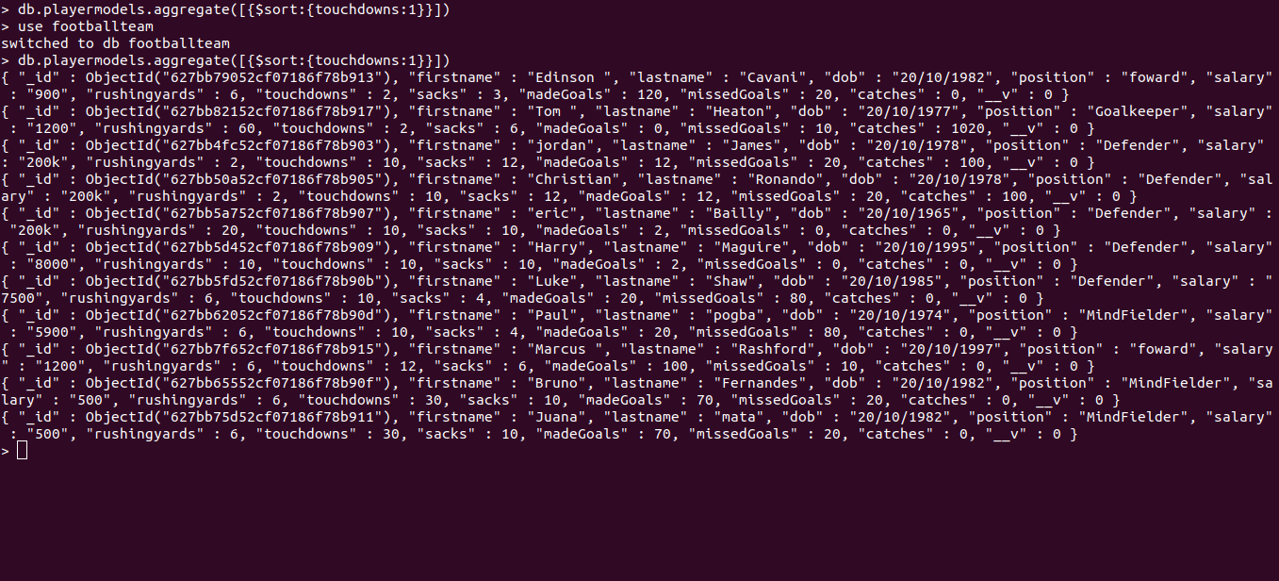
The player with most rushing yards

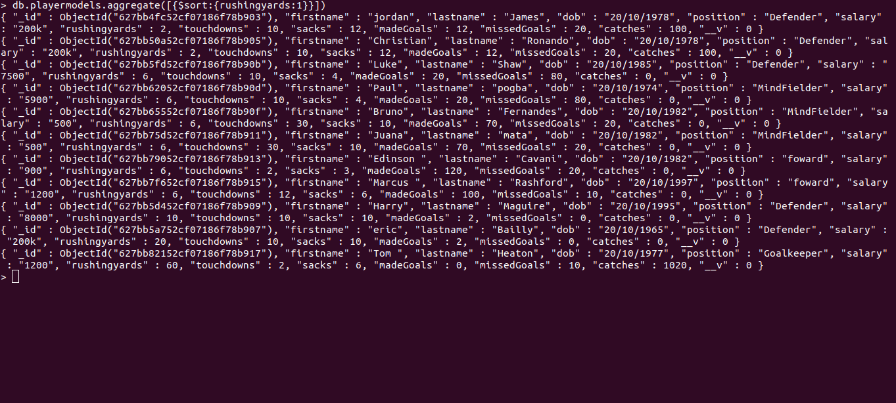

The player with lest touchdown passes
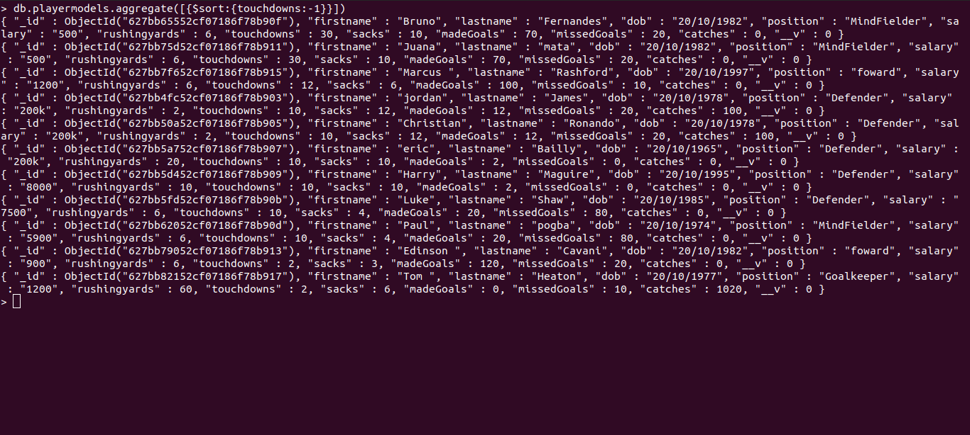
list of players sorted from most to fewest field goals made
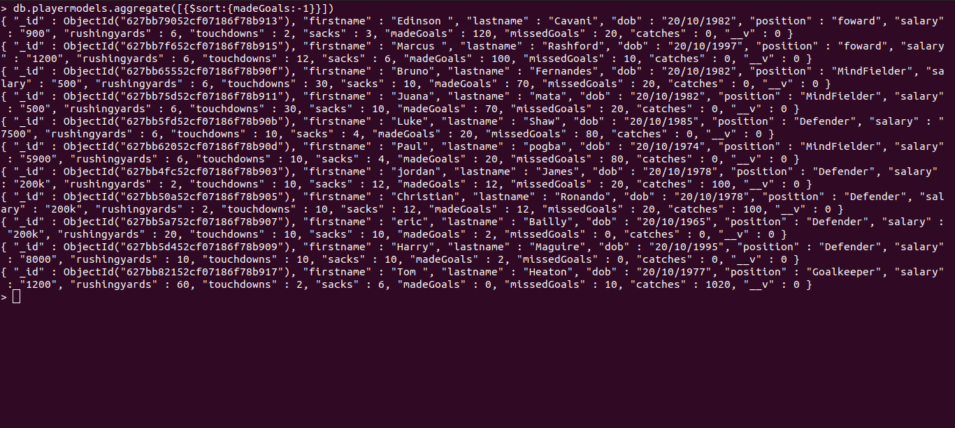

The player of the most sacks
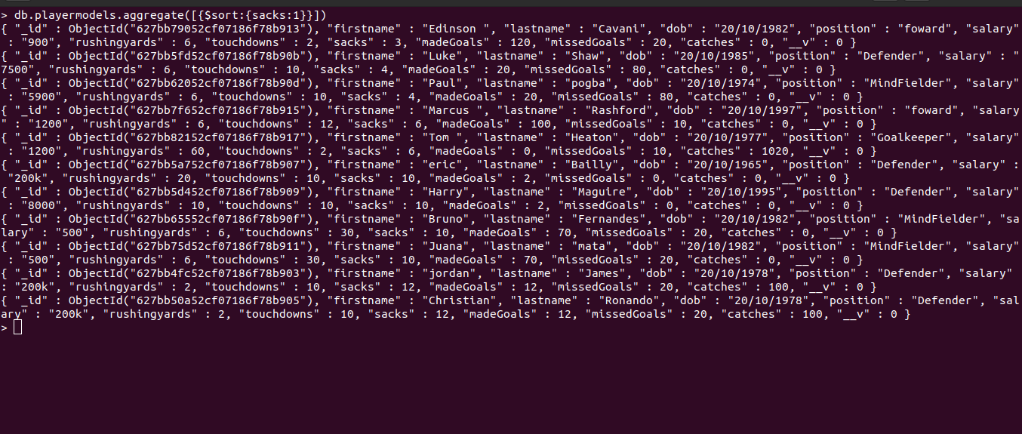
The player with lest sacks

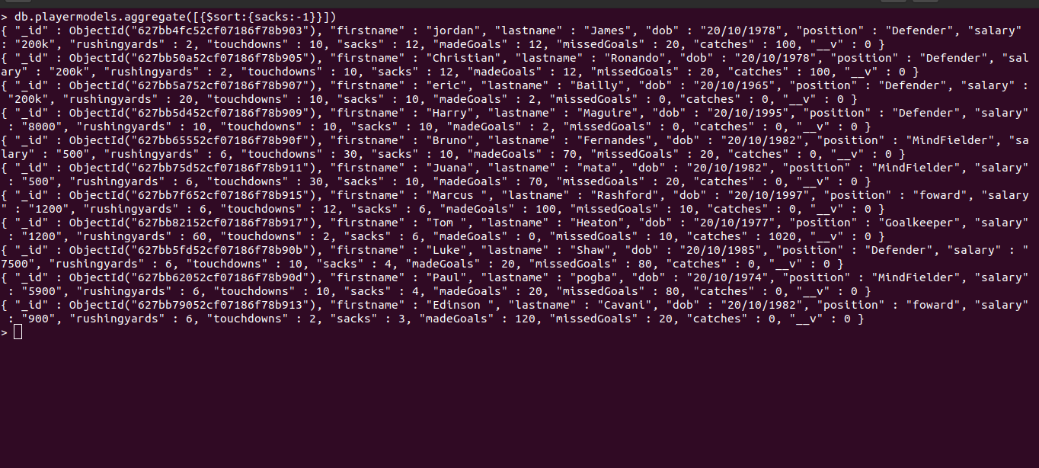

Summary
while tackling this assignment I was having hard time to recall the syntax for MongoDB especially because I was using a terminal I had to keep them at the finger tips .
I was also struggling with remembering to switch to the table I wanted to query
MongoDB has weird syntax but I was able to understand then and implement them successfully with time and practice

